***PROGRAMMING FUNDAMENTAL LAB# 9 TASK:***

***Name: SHERALI***

***ROLLNO: P21-8024***

***SECTION: BSCS-1A***

***QUESTION1: PART(A)***

num=int(input("enter number "))

for i in range(1,num+1):

print("*"*i)

***OUTPUT:***

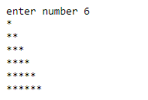

***PART(B):***

num=int(input("enter rows "))

for i in range(1,num+1):

print(" "*(num-i)+"*"*i)

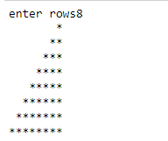***OUTPUT:***

***PART(C):***

num=int(input("enter rows "))

for i in range(num,0,-1):

print("*"*i+" "*(num-i))

***OUTPUT:***

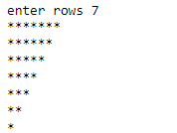

***PART(D):***

num=int(input("enter rows"))

for i in range(num,0,-1):

print(" "*(num-i)+"*"*i)

***OUTPUT:***

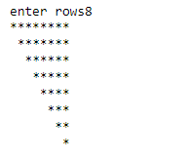

***QUESTION(2): PART(A)***

***Enter symbol “#” or “*” or “@” what ever you want program run according to it; I have used “*” or “#” both symbol:***

num=int(input("enter rows "))

for i in range(1,num+1):

print("*"*i)

for i in range(num-1,0,-1):

print("*"*i+" "*(num-i))

***OUTPUT:***

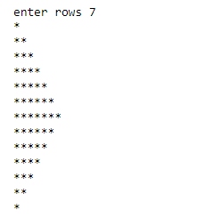

***PART(B):***

num=int(input("enter rows "))

for i in range(1,num+1):

print("#"*i)

for i in range(num-1,0,-1):

print("#"*i+" "*(num-i))

***OUTPUT:***

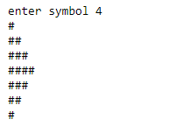

***QUESTION3:***

y=1

for i in range(3):

x=str(input("enter the name of student"+str(y)+':'))

y+=1

for j in range(1):

a=int(input("enter score 1:"))

b=int(input("enter score 2:"))

c=int(input("enter score 3:"))

avg=(a+b+c)/3

print("Name",x)

print("Average=",round(avg,2))

***OUTPUT:***

